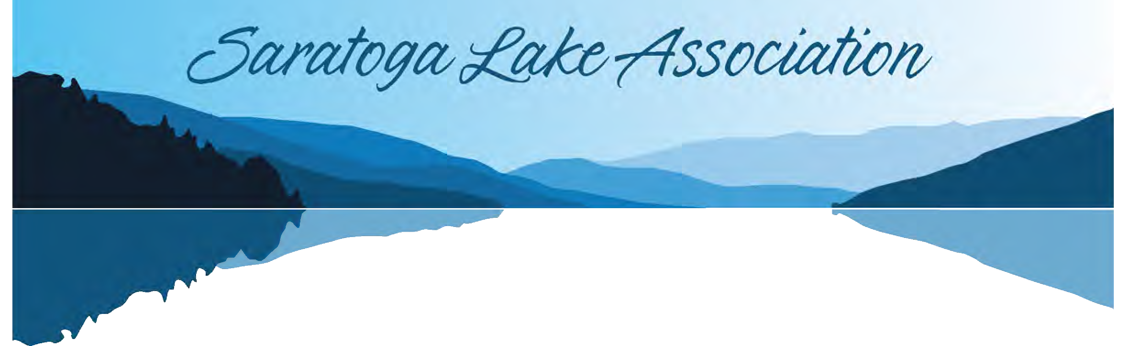
Dear Friends, 2023
The Saratoga Lake Association (“SLA”) is a not for profit organization that promotes and enhances the health, safety, sanitation, recreation and environmental quality of Saratoga Lake and its extensive watershed.
Membership is only $30 a year per individual. Family Memberships are $50 and are only available to individuals eighteen years of age or above that each reside in the same principal residence. A Family Membership shall be limited to two votes with the specific family individuals entitled to vote designated at the time of each vote. With respect to families that have more than two eligible members, the third or more family members are eligible for the member pricing (including any discount) on events even though they cannot vote or be counted as part of a quorum. Business Membership shall be limited to one vote.

Paperless Online Membership Application:
https://www.joinit.org/o/saratoga-lake-association

Over 600 individuals committed to our mission have joined the SLA. Although we have accomplished a great deal, we need to keep our momentum going and the best way to do that is through your support as a member.
With multiple new public access points including the City of Saratoga Springs Waterfront Park and the Town of Stillwater’s Brown’s Beach, our community has expanded well beyond the lake borders. You do not have to live on or own property on the lake to be part of the SLA. SLA has an Annual Meeting in July and informational meetings when needed.

Among our activities are:

- Boat safety and paddle safety courses
- Adopt-A-Highway roadside clean-ups
- Networking get-togethers
- Educational programs
- Online business directory
- Award winning newsletter and rapidly growing Facebook page
- Annual and informational meetings
- Holiday party with old and new friends and neighbors
- Cocktail party on the veranda at Saratoga National Golf Course
- Collaboration with and outreach to other lake-based organizations and
municipalities
- Programming at public access parks
- Identify and resolve issues of concern

- We strive to offer a wide variety of events that appeal to all and foster a sense of community. These activities allow you to meet your fellow lake neighbors, network, and make new friends.
- Membership to SLA comes with some very nice benefits. Shore Lines, our award-­‐winning newsletter, and our rapidly expanding Facebook page bring our lake community together with events, neighborhood news, photographs, issues of concern and historical reminisces. The newsletter is electronic, so it is important that we have your correct e-­‐mail. Let us know if you have difficulties receiving our emails and we can confirm that we have the correct email or obtain an alternative.

Our membership year begins on January 1 and ends December 31. We must receive your membership dues
prior to February 15, 2023 in order for you to continue receiving SLA communications.

Please fill out the enclosed Membership Form without delay and return your membership fee in the envelope provided. Use a separate form for each individual. If you have a change of contact information, make sure we receive your updated information. If you no longer wish to be on our mailing list, let us know by returning the enclosed form or notifying our Membership Chair, Eileen Seery at membership@saratogalake.org.
SLA is an IRS charitable not-­‐for-­‐profit organization; however, dues may not be tax deductible because of incidental benefits that may be provided. Any amounts in excess of dues are tax deductible.
Our By-­‐Laws require ten percent of our members to constitute a quorum to conduct business at our Annual Meeting. Since many of our members are not full-­‐time residents, this year we are asking you to complete a proxy. If you come to the meeting, the proxy can be voided. Please complete the proxy at the end of the Membership Application Form. Please note that you must: (1) list the name and address of the individual to whom you grant your proxy: and (2) obtain his or her signature. The individual that you identify must be a member in good standing. If you are unsure about whether an individual is a member in good standing, you may wish to appoint a Saratoga Lake Association Board Member such as the Secretary of the Board.
We hope you will stay or become a member of this great community organization.

Sincerely,

Eileen Seery
Membership Chair
Hubert Miller
Board President

Membership Form
Eileen Seery, Membership Chair membership@saratogalake.org
MISSION STATEMENT: The Saratoga Lake Association (SLA) is a Not-for-Profit Organization. The Association’s purpose is to promote and enhance the health, safety, sanitation, recreation and environmental quality of Saratoga Lake and its extensive watershed.
Please Note Membership will now be done only on a Yearly Basis. Those who paid for 2 years will be carried over into 2023
Membership Tiers (Please choose one of the two options, not both) Residential:Individual & Family and Business
Online Membership Renewal: Renew your membership online via joinit.org/o/saratoga-lake-association INDIVIDUAL MEMBERSHIP DUES — JANUARY 1, 2023 TO DECEMBER 31, 2023 ̶ $30
Any amount in excess of the normal dues we receive will be applied as a donation. DEADLINE FOR PAYMENT OF DUES IS February 15, 2023.

$ 2023 Only $ Charitable Donation $ Total Amount Enclosed

PLEASE PRINT (MUST BE AT LEAST 18 YEARS OF AGE)
Name
Permanent Home Address
Street City State Zip

Telephone
Lake Address

Email Address (print clearly)
Member Involvement:
How would you like to become more involved as an SLA member? ________________________________________________________________

FAMILY MEMBERSHIP DUES — JANUARY 1, 2023 TO DECEMBER 31, 2023 ̶ $50
Important: Family memberships are only available to individuals eighteen years of age or above that each reside in the same principal residence. A Family Membership shall be limited to two votes with the specific family individuals entitled to vote designated at the time of each vote. With respect to families that have more than two eligible members, the third or more family members are eligible
for the member pricing (including any discount) on events even though they cannot vote or be counted as part of a quorum.
Any amount in excess of the normal dues we receive will be applied as a donation.

$ 2023 Only ($50) $ Charitable Donation

PLEASE PRINT FOR EACH FAMILY MEMBER (MUST BE AT LEAST 18 YEARS OF AGE)
$ Total Amount Enclosed

Name
Permanent Home Address
Street City State Zip
Telephone Lake Address Email Address (print clearly)

PLEASE PRINT
Name
Permanent Home Address
Street City State Zip _
Telephone
Lake Address

Email Address (print clearly)

PLEASE PRINT
Name
Permanent Home Address
Street City State Zip
Telephone
Lake Address

Email Address (print clearly)

PLEASE PRINT
Name
Permanent Home Address
Street City State Zip
Telephone
Lake Address

Email Address (print clearly)
Member Involvement:
How would you like to become more involved as an SLA member? ________________________________________________________________

BUSINESS MEMBERSHIP DUES — JANUARY 1, 2023 TO DECEMBER 31, 2023
Businesses have the opportunity to invest in the community by becoming a member of SLA. Business Membership shall be limited to one vote. Business members are provided the following benefits based on their membership tier:
-Listed on the SLA online business directory
-Recognized in our newsletter that reaches over 600 members of the local community
-Name and logo will be included in event press releases
-Name and logo will be on the corporate sponsorship stationery
-Name and logo will be on the corporate boards showcased at all SLA events
-Recognition of your company in SLA’s Annual Report
Membership-- We have combined Silver and Gold to only one Level. Business Membership will now be done on a yearly basis only
$ 2023 Only ($150) $ Charitable Donation $ Total Amount Enclosed

Name of Business
Same as current listing New or modified listing
Type of Business

Address Telephone Your Position Comments

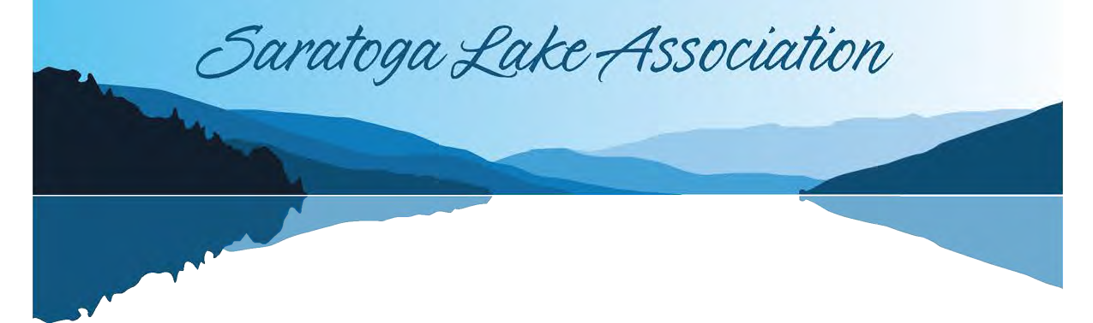
SARATOGA LAKE ASSOCIATION PROXY
BY ORDER OF THE BOARD OF DIRECTORS, SARATOGA LAKE ASSOCIATION,
and recorded by, Michelle Merola, Secretary

I of Name

Address

being a member in good standing of the Saratoga Lake Association (hereinafter “Association”) do hereby grant my proxy, for the entire duration of my current membership term, to:

of Name

Address

or failing the individual named, his or her appointed proxy, or failing said proxy, to the appointee of the Secretary of the Association, said person having duly represented himself/herself as being a member in good standing of the Association to act generally at the Annual Meeting in 2023 and, if authorized by my proxy, the Annual Meeting in 2024 to be held in July of the respective year, or any other adjourned date, on my behalf to establish a quorum, vote as he/she decides on any issue, and to vote as my proxy at such Annual Meeting, whenever held, or any adjournment thereto, for the transaction of any business which may legally come before the meeting, and for me in my name, to act as fully as I could do if personally present; and I hereby revoke any other proxy heretofore given.

Signature of Member Signature of Proxy

_

Date:
Please note that you must: (1) list the name and address of the individual to whom you grant your proxy; and (2) obtain his or her signature. The individual that you identify must be a member in good standing. If you are unsure about whether an individual is a member in good standing, you may wish to appoint a Saratoga Lake Association Board Member such as the Secretary of the Board.

